**HL DENTAL CLINIC**

**GROUP 4**

**FIRST MEETING PREPARATION**

**Members:**

|  |  |  |  |
| --- | --- | --- | --- |
| **No.** | **Full name** | Title | Evalutation |
| 1 | Trần Tuấn Anh | Member | Good |
| 2 | Chu Bạch Dương | Member | Good |
| 3 | Lê Hữu Hiệu | Member | Good |
| 4 | Vũ Thị Lan Anh | Member | Good |
| 5 | Trần Ngọc Nguyên | Leader |  |
| 6 | Nguyễn Ngọc Hân | Member | Good |
| 7 | Nguyễn Thị Bích Diệp | Member | Good |
| 8 | Lê Hải Anh | Member | Good |
| 9 | Trịnh Hương Ly | Member | Good |
| 10 | Nguyễn Thị Tú Bình | Deputy | Good |

**TABLE OF CONTENT**

I. PROJECT INTRODUCTION 2

II. BACCM ANALYSIS 2

Contexts 2

Stakeholders 2

Needs 2

Changes 3

Solutions 3

Values 3

III. DEMAND AND CLASSIFICATION ANALYSIS 3

Values/Benefits 4

Functions 4

Features/Utilities 5

IV. QUESTIONS LIST 6

# I. PROJECT INTRODUCTION

**• Trainer:** HL is a dental clinic which is operating in Vietnamese market. Because HL Dental Clinic wants to expand the market, the company wants to build a mobile app for customers to improve the user experience and customer service. HL dental clinic already has the internal management system.

**• Student:** As a Business Analyst role (BA) of a software company, you are required to develop a solution to satisfy HL dental clinic’s demand.

# II. BACCM ANALYSIS

With BACCM model, we have first analysis from HL’s requirement

## Contexts

* Improve user experience and customer service at HL Dental Clinic

## Stakeholders

* Customers at HL clinic
* HL Dental clinic
* Sofware company

## Needs

Problems:

Contact:

* Customers hardly get the contact and information of the dentist
* Customers can’t keep up with ads/sale-off/information from HL’s dental branch
* Customers hardly follow their treatment and check-up schedule

Service:

* Difficult to collect feedbacks and reports from customers
* Difficult to provide immediate support to customers
* HL's internal management system is not optimal: Customer information is updated slowly and lacks, causing the customer service department to not fully grasp customer information to advise and support

Opportunities:

* Increase customer experience: easy to follow up with regular check-up schedule, easy to update oral health status with the doctor and schedule the most convenient appointment, supported in an emergency
* Convenient for exchanging and connecting customers with employees
* Optimizing the process of using, searching, and consulting HL clinic services from a smartphone
* Increase brand recognition to attract more customers
* Decrease website system is overloaded
* Higher chance the customer will comeback

## Changes

* Customers' habits regarding the service experience
* How to store and track customer information
* Limit and overcome the inadequacies when accessing the website
* Data security support

## Solutions

* Use a QR code for each customer
* Create appointment reminders when approaching an appointment via SMS
* Call to remind in advance
* Building a mobile app system

## Values

* Expand the market, reach more customers
* Bring safety and convenience to customers

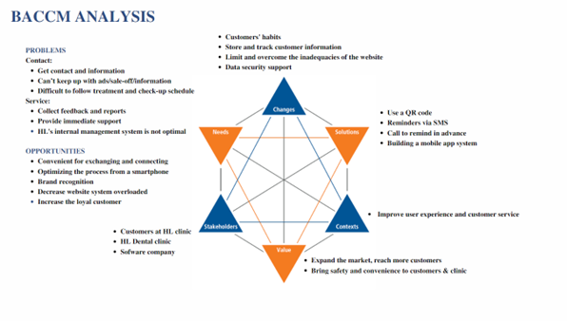

# 

# III. DEMAND AND CLASSIFICATION ANALYSIS

|  |  |  |  |
| --- | --- | --- | --- |
| **No.** | **User** | **Demand** | **Note** |
| 1 | Customers | - Schedule orthodontic plans and get notified when nears the date - Receive information, discounts from the dental  - Get quick supports when needed  - Pay bills  - Send feedbacks, ratings  - Create an account quickly  - Check dentists’ profiles |  |
| 2 | Customer service team | - Receive feedbacks from customers  - Connect immediately with customers  - Recommend services to customers |  |
| 3 | Receptionists | - See information (name, number, time of the date, dentist in charge) and orthodontic plans of each customer  - Plans organized in chronological order  - Remind the calendar’s customer for the next time  - Recommend services to customers |  |
| 4 | Marketing team | - Create, read, update, delete posts/ads  - Get report about reach and engagement at each post  - Remind the promotion campaign via email’s customer |  |
| 5 | Dentists | - Check schedules for each day  - Get notified before the schedule  - See information, symptoms of patients |  |

## Values/Benefits

Build a mutual and easy way to connect customers and dental -> improve customer experience and customer service

## Functions

* + For customers:
    - Create account by email, phone number
    - Log in/log out account by email, phone number
    - Create, read, update, delete feedbacks
    - Set or cancel a schedule with dentist
    - Read news, notifications or discounts from dental
    - Chat with customer service team
    - Pay the bills online
    - Create patient’s profile online (personal information, symptoms, what they want to do/have already done, notes about health, allergies)
  + For dental:
    - Receive and reply feedbacks, helps from customers
    - Log in/log out account by email, employee ID
    - Store customers’ information and enable to search for
    - Store schedules and organize in chronological order
    - Notify when there is schedule
    - Create, read, update, delete posts, ads
    - Create reports for tracking performance

## Features/Utilities

* + Menus: patients' personal information, medical history, dental charts, dental notes, photos, payment history, dental news, reports/rating
  + Connect bank accounts, e-wallet, credit card to the app
  + Connect email, phone number, employee ID
  + Appointment reminders
  + AI Chatbot 24/7
  + Pop up ads & Promotions: Inform patients of any ongoing promotions. Send birthday greetings, welcome emails, newsletters, etc.

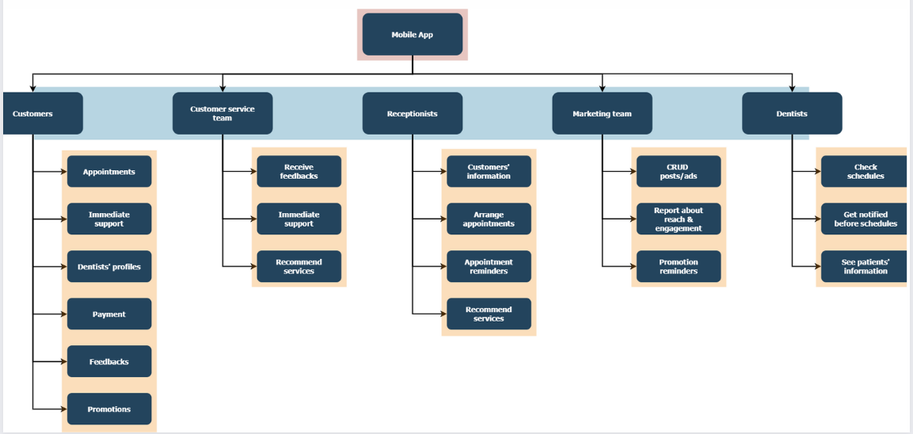

# IV. QUESTIONS LIST

My team has a list of questions about mobile app products when they start developing in the near future.

|  |  |  |
| --- | --- | --- |
| **No** | **Questions** | |
| **Components** | **Questions** |
| 1 | **General** | Is this app availlable on both IOS and Android? |
| 2 |  | Do you have any preferred program languages? |
| 3 |  | What is the customer demographic that the mobile app targets? |
| 4 |  | How many languages does this app support? |
| 5 | **Srceen** | Does this app support all resolution? |
| 6 |  | Does this app support landscape mode? |
| 7 | **Product Content** | How can the clients receive immediate support from the dentist? |
| 8 |  | How dentists can keep track of clients progress? |
| 9 |  | Do we need to notify the clients to follow their treatments? for example: drink medicines, wear braces |
| 10 |  | How dentists can keep track of clients progress? |
| 11 | **Product Operation & Resources** | Does this app have the admin portal come with it? |
| 12 |  | Can the data from your internal system be connected to the app? How much data are we expecting? |
| 13 | **Authentic** | When sign-up validate from mobile phone number/email? |
| 14 |  | Is this phone number/email need to verify when user logging in? |
| 15 |  | In case of requesting to re-issue password when user forgets, need to confirm via phone number/email |
| 16 | **Other** | Does this app have the admin portal come with it? |